# Plant Development I - Plants are composed of repeated structural units

### 3 directions of plant growth:

* Apical growth: up/down, phototropism, linear
* Branching: lateral growth to explore the ground
* Radial growth: thickening stems or roots

### 3 tissue systems:

* Epidermal
* Vascular
* Ground (everything else)

### Simple tissue:

* Parenchyma - cell walls unmodified, often storage or metabolic cells
* Epidermis - cuticle with cutin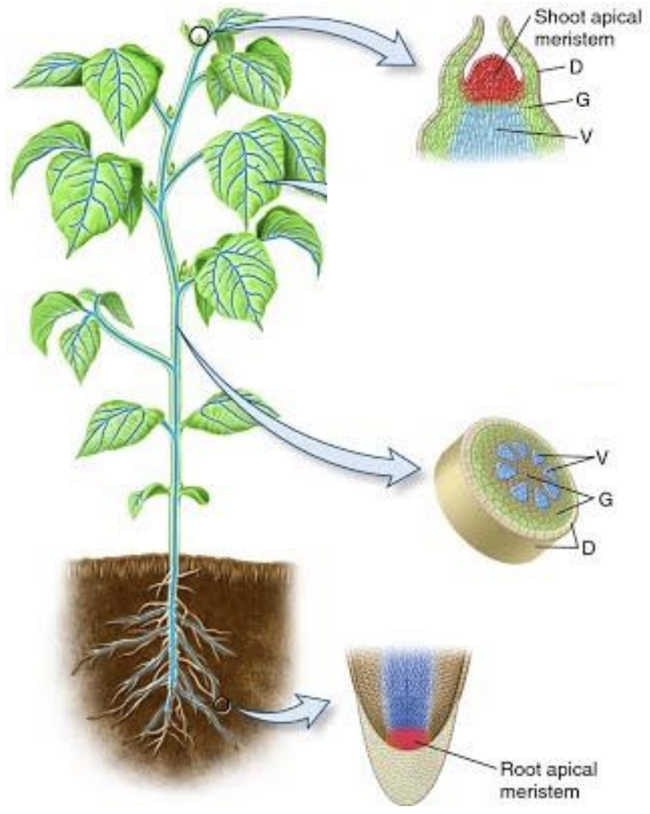
* Collenchyma - thickened cell wall with pectins (for tensile strength)
* Sclerenchyma - thickened cell wall with lignin/suberin

### Meristems

* In the root & shoot apices, the RAM & SAM
* Also in the cambia: in stem/roots, for thickening of these
* Can regenerate from differentiated tissues,
* e.g. regeneration of roots from differentiated tissues to return to RAM cells
  + *Known as “adventitious roots”, e.g. from cuttings!*
* This high regenerative capacity is in compensation for sessility of plants, to protect from e.g. herbivores
* It allows for damaged plants to reactivate silenced meristems or regenerate new ones e.g. after wildfires
* Meristematic cells can be visualised by linking e.g. GFP to specific enhancers & promoters which are only expressed in meristems
* In the centre are 4 cells, the **quiescence centre**, with very little division, but which define nearby cell identity

Most plants develop post-embryonically, with a very simple embryo, contrary to how animals develop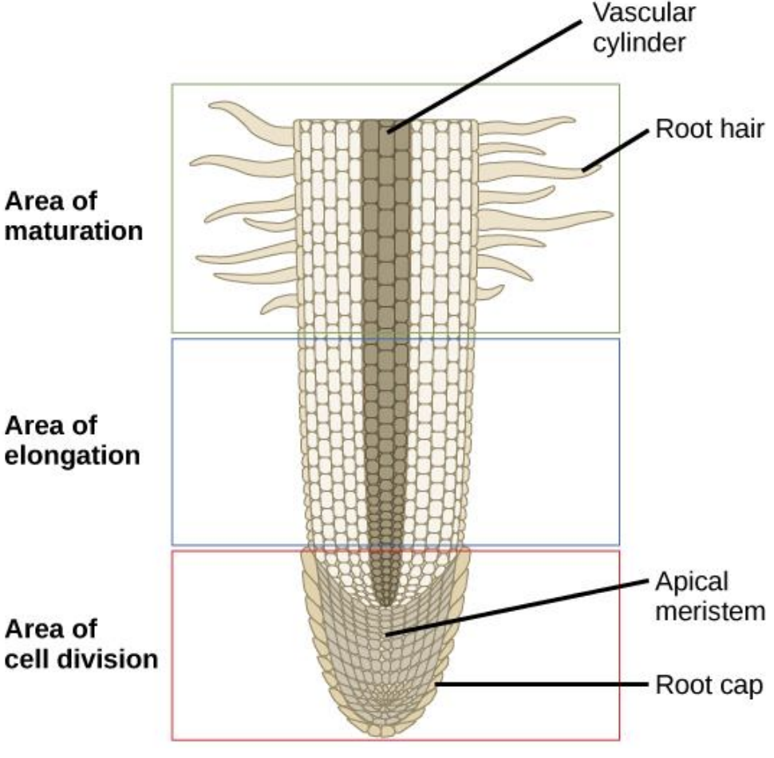

### 3 parts of the root

* Division zone
* Elongation zone
* Differentiation zone

### The roots & RAM

* In the distal part of the RAM, cells differentiate to gain specific functions, e.g. epidermal cells in contact with *exactly 2 cortical cells* form root hair cells for nutrient/water uptake
* Central cells differentiate into the xylem and phloem
* Lateral root primordia only occur after sufficient growth further down the root

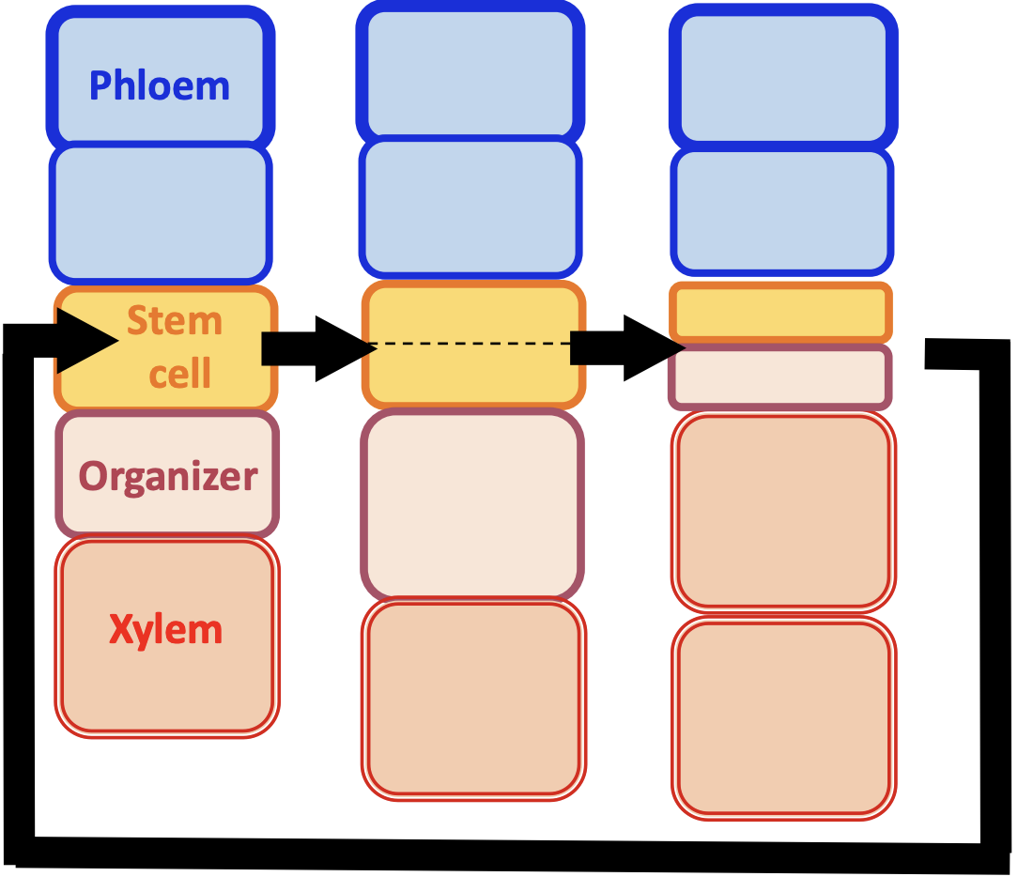

### Cambial meristems

* New xylem & phloem produced in cambial meristems
* Organiser cells → xylem cell
* Stem cell → stem cell + organiser cell

### The SAM

* Embedded in layers of leaves/leaf primordia to protect it
  + *As a consequence it is harder to study*
* Proliferation of the SAM forms phytomers:
* One phytomer = 1 node + 1 internode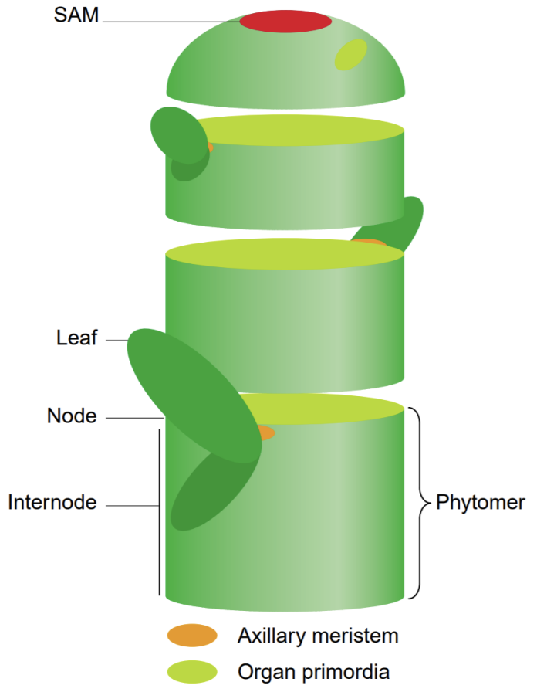
* = leaf + axillary meristem (dormant) + internode

### Phytotaxis

* Position on stem of the new leaf relative to the last leaf
* Alternate: 180o
* Opposite & decussate: 90o
* Whorled: 45o
* Spiralled: 137o

**Plastochron** = time interval between production of two consecutive phytomers

### Leaves

* All 3 layers of cells in the SAM produce new leaves
* Leaf shape is determined by gradients of growth
* Compound leaves are made of leaf subunits connected by bladeless regions
* Simple leaves are one single undivided blade
* Adaxial = upper face
* Abaxial = lower face
* Polarity of leaf blade is established early in leaf primordia by proximity to SAM (chemical gradient)

Mature meristems can become reproductive meristems (RM), which differentiate into more RMs or flower meristems

Terminal flower meristems define flower architecture by how they branch to form organs

### ABC(DE) genes

* 4 floral organs, arranged concentrically in the meristem
* Homeotic genes control production of these, so mutations of these lead to unusual flower heads
* A: sepals
* AB: petals
* BC: stem
* C: carpels
* E gene was discovered to be necessary for flower growth, as knockouts produce leafy flowers
* D mutations have high redundancy, but have been found to produce the ovary
* A and C are mutual inhibitors

